1.
Number 1: 1010 0101 1010 0101
Number 2: 1011 1111 0100 1110
Number 3: 1110 0001 1100 0111

Sum of Number 1 + 2: 1 0110 0100 1111 0011
Wrap around sum: 0110 0100 1111 0100
That plus Number 3: 1 0100 0110 1011 1011
Wrap around sum: 0100 0110 1011 0100
Flip bits: 1011 1001 0100 1011
2.
A. 2000/1Mbps = 0.002. The packet takes .002 seconds on each link. The process will take .004 seconds total.
B. 1000/1Mbps = 0.001. The packet takes .001 seconds on each link. Since there are two packets and the second must wait for the first to transmit at the first link, it will take a total of .005 seconds to reach the destination.
C. 500/1Mbps = .00005. The packets transmit across the first link in increments of .0005 seconds, and then each take .0005 seconds at the second link. In total, it takes .0070 seconds for all packets to reach the destination.
3. 10km x (2x10^8)m/s = 2 x 10^12s. Which is just added to all the parts above, we get:
A. 2 x 10^12 + 0.002
B. 2 x 10^12 + 0.001
C. 2 x 10^12 + 0.007
4.
A. 2 RTT
Client sends small TCP message, Server responds with small TCP acknowledgement
Client sends GET with acknowledgement, Server responds with HTTP response
B. 10RTT
Client sends small TCP message, Server responds with small TCP acknowledgement
Client sends GET with acknowledgement, Server responds with HTTP response
Client sends small TCP message, Server responds with small TCP acknowledgement
Client sends GET with acknowledgement, Server responds with HTTP response (Pic 1)
Client sends small TCP message, Server responds with small TCP acknowledgement
Client sends GET with acknowledgement, Server responds with HTTP response (Pic 2)
Client sends small TCP message, Server responds with small TCP acknowledgement
Client sends GET with acknowledgement, Server responds with HTTP response (Pic 3)
Client sends small TCP message, Server responds with small TCP acknowledgement
Client sends GET with acknowledgement, Server responds with HTTP response (Pic 4)
5. Max Achievable throughput for each of the three connections; bottleneck link:
A-D: 100Mbps; 4
B-E: 50Mbps; 6
C-F: 100Mbps; 4
6.
A. n/a (going to be even less than 1Mbps, because Kbps is less than Mbps
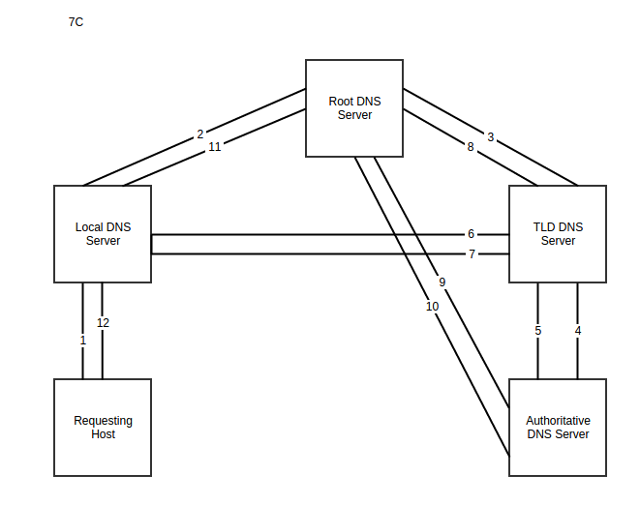
B. n/a
C. (500pac/sec x 1000bits/pac) / 1Mbps = 2 : infinite queuing delay/guaranteed packet loss
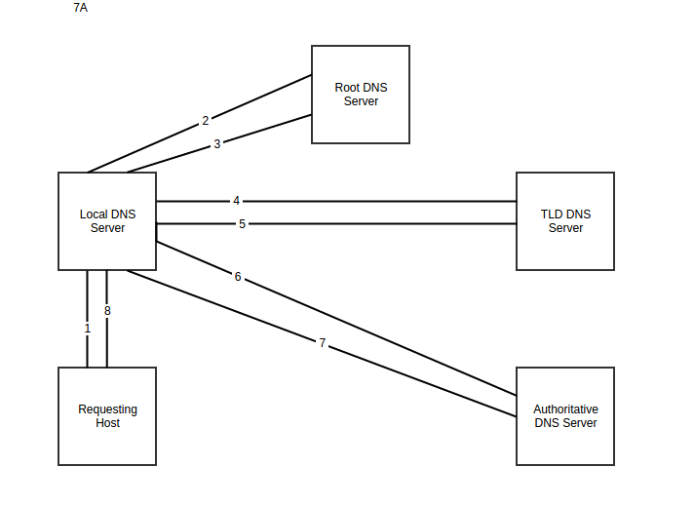
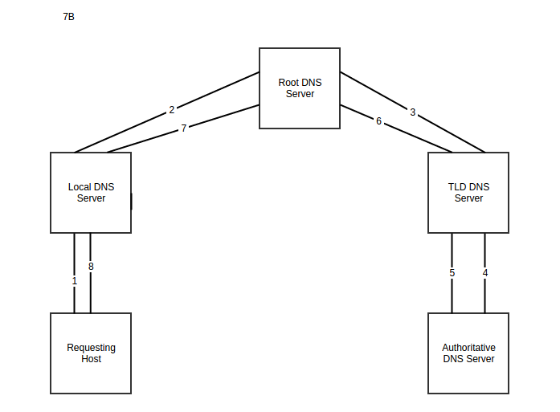
7.

